Duncan Propellers Limited

Dragoon Close, Heathfield Industrial Estate, Newton Abbot, TQ12 6TU

United Kingdom

Phone +44 (01626) 836258
Fax +44 (01626) 832480
Email sales@duncanpropellers.com

Propellers that will make a difference to your boats performance

Duncan Propellers Ltd specialises in the design and manufacture of marine propellers and stern-gear systems. Its management and employees have a wealth of past experience in the propeller industry. The company has the whole manufacturing process “in house” including design office, pattern-making, foundry, machine-shop, finishing shop and inspection.

The company use the most advanced manufacturing techniques in conjunction with special, purpose-built equipment. This ensures that customers receive products of the very highest quality at a competitive price.

Duncan Propellers has a continuing policy of development and improvement to better serve its customers.

A pair of 32” five blade high class propellers as supplied to Princess Yachts International | 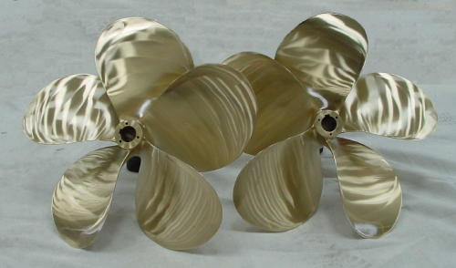

Background

The company’s staff have a great many years of background and experience in the propeller and stern-gear manufacturing industry. Although specialising in high-speed applications, propulsion systems are designed and manufactured for all types of vessel from super yachts to military and fishing boats.

The business is owned by David Duncan and David Hunt who both trained as design engineers in a gas turbine blade manufacturing company. David Duncan first started in marine propeller manufacturing in 1974 when, with a partner, he founded Teignbridge Propellers. David Hunt joined Teignbridge Propellers soon after and the company quickly grew into the Teignbridge Propulsion group. The group eventually consisted of nine different manufacturing companies in five different countries. It established itself as a market leader in the design and manufacture of marine propeller and stern-gear.

In 1997 Dave Duncan sold the Teignbridge group and started Duncan Research and development in order to carry out research and development in the marine field. The company has developed and patented several new ideas. The company has won two awards for innovative design.

After watching the decline of his old company and armed with newly developed manufacturing methods, he decided to re-enter the propeller industry and Duncan Propellers was born.

The Building

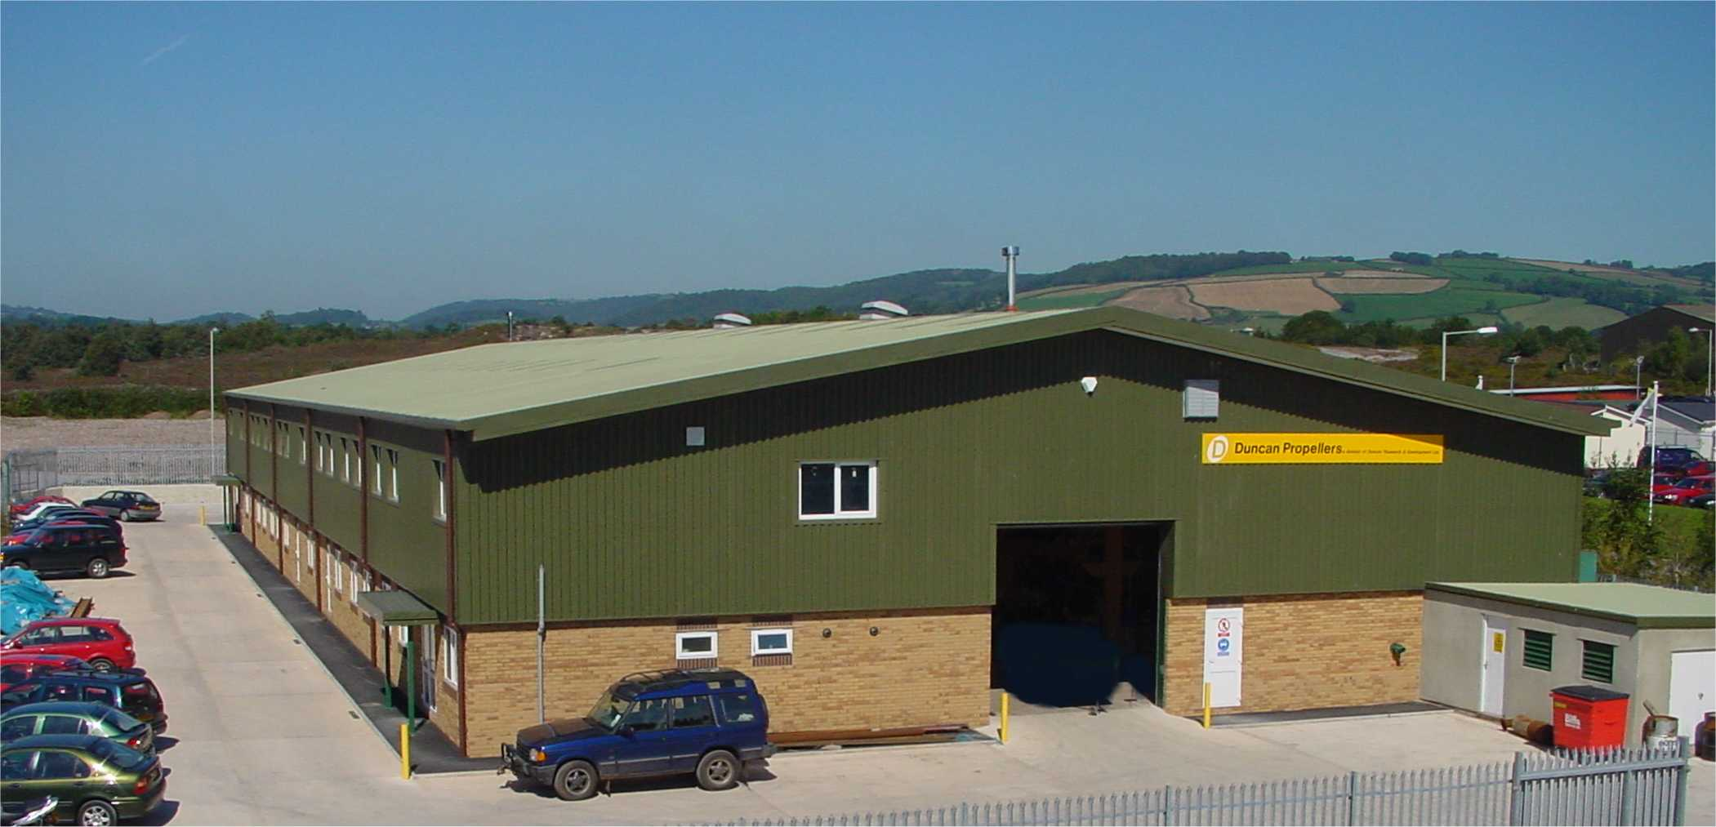

The building is purpose-built and has 20,000 square feet of floor area. It houses a modern propeller and stern-gear manufacturing facility including design office, pattern-making shop, foundry, machine shop, finishing shop and inspection.

World class custom design with unbeatable delivery lead times

Design and Pattern-making

Selection Design

The company uses propeller and stern-gear selection design programs that have been specially developed over a number of years and with the past experience of designing the installations of a great many high performance boats. These include naval vessels, super yachts, fast patrol boats, lifeboats, coast-guard vessels, high performance sports boats and many more.

Propeller Design

After a period of development, Duncan Propellers has recently introduced a new style of high performance propeller.

The new form of custom designed propeller uses blade geometry, which produces optimum flow, for smooth and efficient thrust. The new design has outperformed its rivals during trials with several different high-speed vessels.

Pattern-making

The company has developed a specialist, and market leading, computer controlled pattern-making process. This process offers two main features over conventional methods. It enables the company to offer a very large number of very accurate standard and custom designed propellers to conform up to ISO “S” class. In addition, the process is very fast and so it reduces the lead-time and the cost of new propellers.

This gives Duncan Propellers a distinct advantage over other propeller manufacturers.

Very high quality castings

The Bronze Foundry

The foundry is equipped with new electric induction melting furnaces for cleaner and purer castings. They consist of two drop down furnaces of 100kg and 250kg capacity and one tilting furnace of 1 ton capacity. The bronze materials used for propeller castings are from certified virgin ingot and the quality of the melt is carefully controlled. The propeller casting method has been developed over a number of years to ensure a high level of cast quality. | 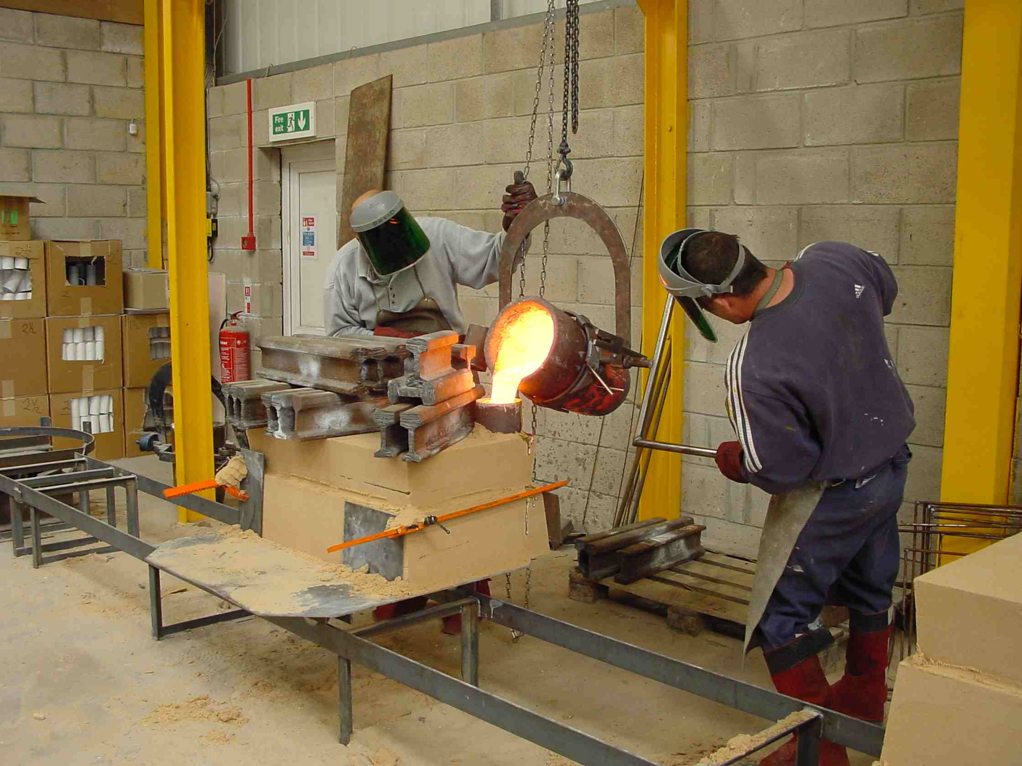

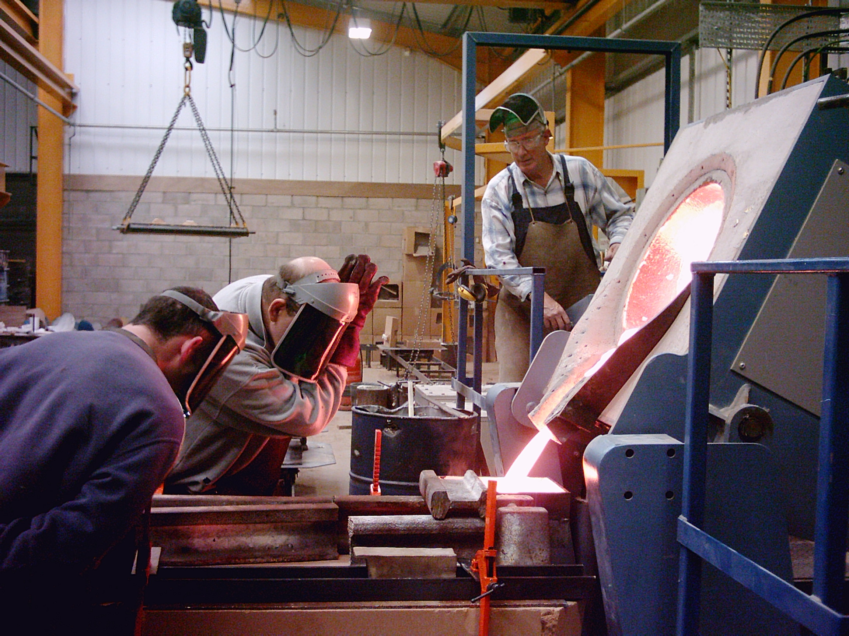

Stern-gear castings such as rudders, shaft-brackets and shaft-bearing housings are also produced.

The foundry is equipped with a recirculating sand system and a mould-handling track system for improved productivity and smooth handling.

Castings up to 1000kgs or 1 ton in weight can be produced.

Skilled and accurate manufacturing

Machine Shop

The photograph shows a C.N.C. (computer controlled) lathe machining a propeller. The lathe has an eight-foot diameter (2.5 metre) swing. | 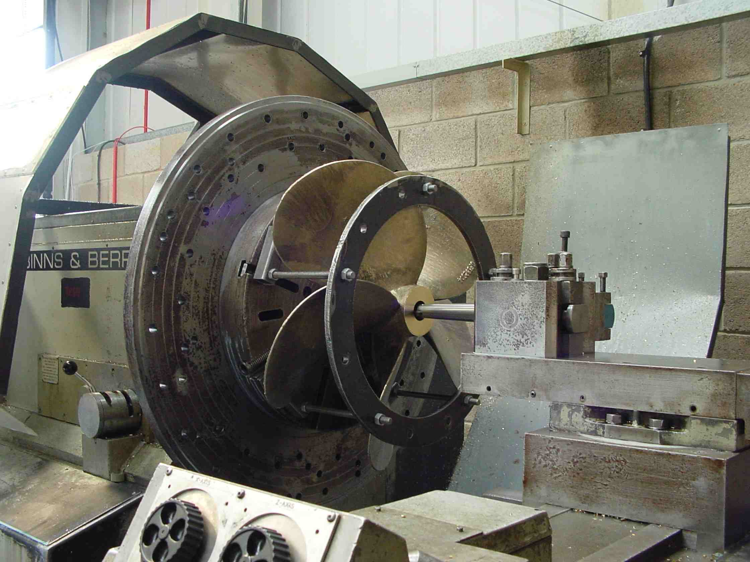

The company produces propellers up to 2.5 metres in diameter, propeller shafts up to 150mm diameter, and a variety of rudders shaft brackets and stern-gear components. These components are machined by highly skilled and trained staff using precision machine tools, special purpose equipment and C.N.C machines.

Smooth vibration free high performance propellers.

Propeller Finishing

Propellers are hand-crafted, finished and balanced by a team of dedicated, skilled and specially trained staff.

The company’s propellers have many refinements in the design and finishing process which differentiate them from other propeller manufacturers’ products. The company’s employees have a clear understanding of what it takes to manufacture a world class propeller. Propellers are manufactured to ISO class S, 1 or 2, depending on the application and are supplied with inspection reports to indicate conformity to design.

Inspection

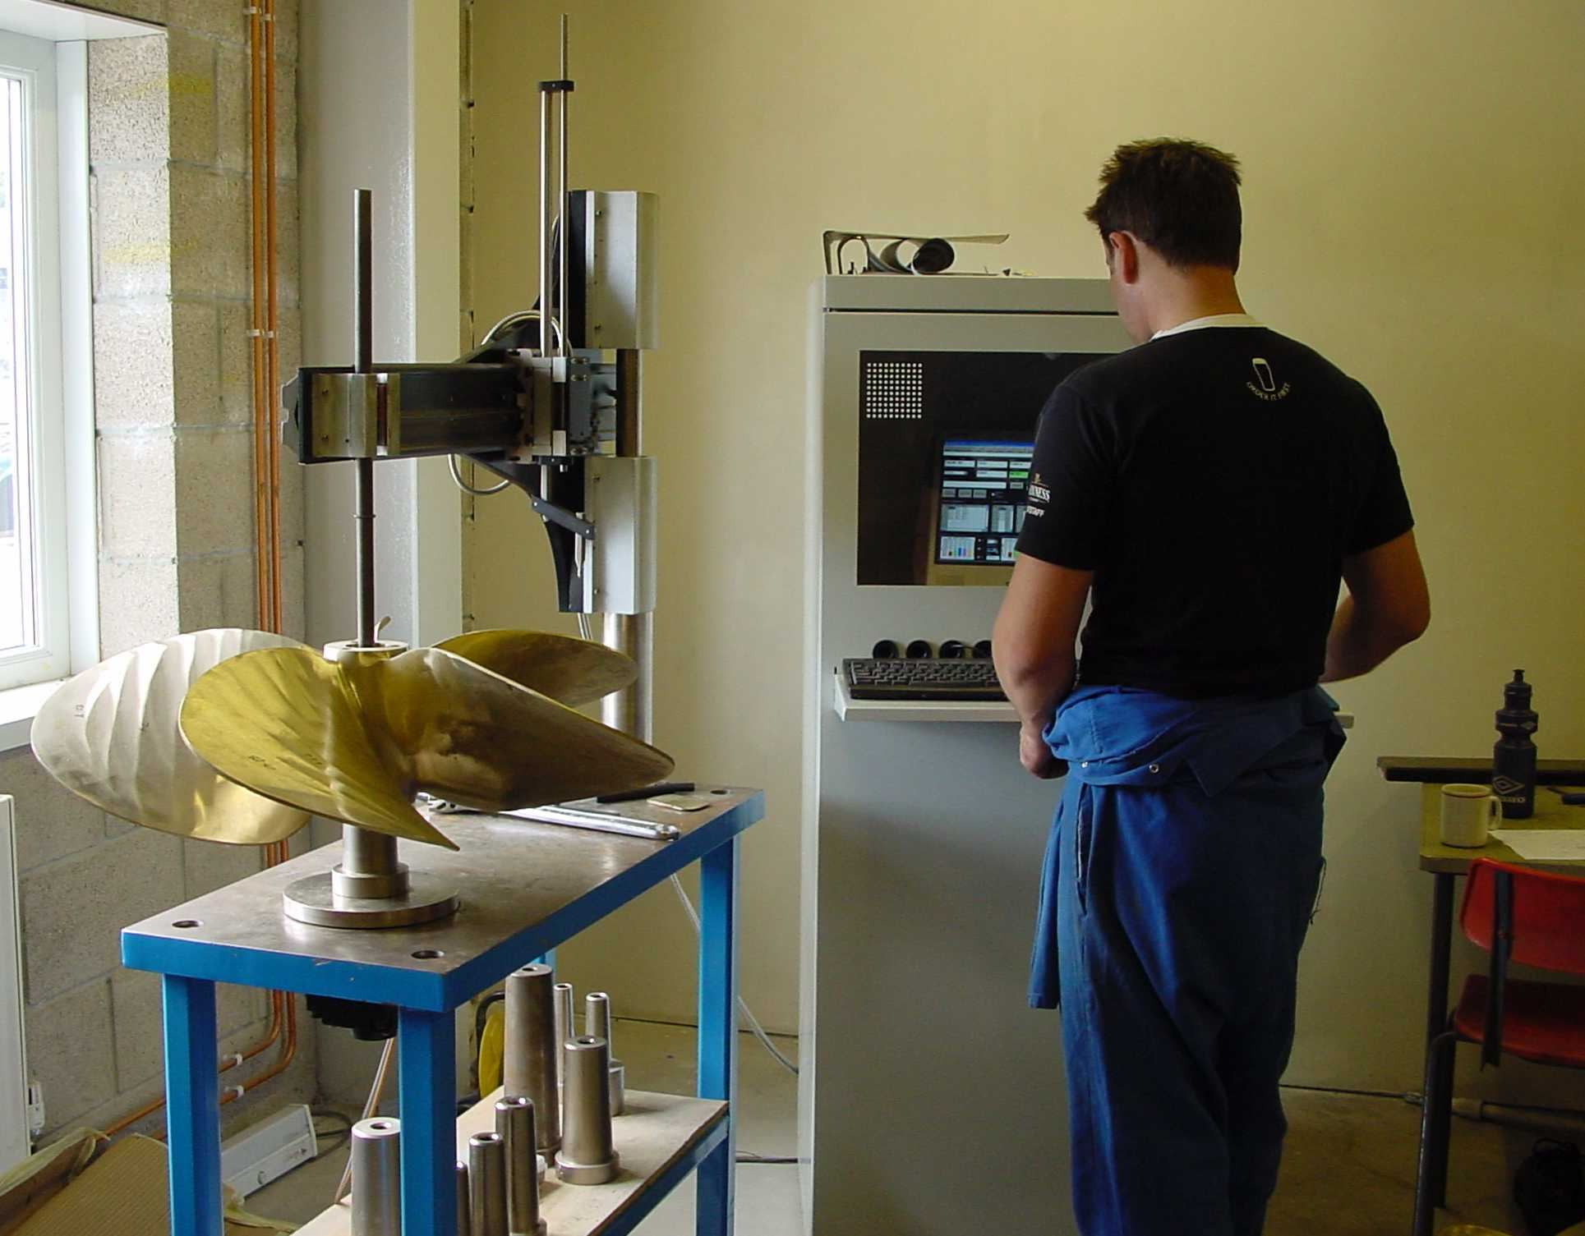

Propellers are inspected using computerised specialist measuring equipment to ensure conformity to propeller inspection standards.

